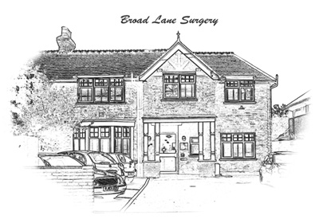

**Information about your Patient Record**

Health records play an important role in modern healthcare. They have two main functions, which are described as either primary or secondary.

**Primary functions**

Contains personal demographic information, ethnic group, next of kin, address, contact numbers, NHS number, consultation notes, significant medical conditions, tests, lifestyle information, correspondence and contact with other healthcare organizations, prescriptions, allergies and any adverse reactions.

These notes enable the practice to manage your health care effectively.

**Secondary functions**

Health care records can also be used to provide information about public health, to monitor the quality and performance of NHS organisations, assessing the effectiveness of existing treatments, looking at epidemiological trends and for research into improved treatment options in the future.

Where information is extracted for these reasons, personal information is omitted and only the relevant clinical data is provided such as the number of patients with a given condition such as diabetes. If personal information is required then the patient’s (or patient’s representative) consent must be sought.

**Can I see my Records?**

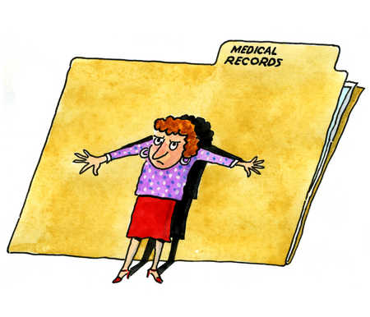

You have a right to see your records. Until now, patients have had to pay a fee of between £10 and £50 to obtain a copy of the records depending on whether the record was a paper version, computerized version or a combination of both since it involves considerable effort by the practice to produce or amalgamate the information. However, in the near future it will be possible to see the patient record online. Initially, it will be a very brief record of your drug allergies and prescriptions but this will be updated and augmented as this facility develops. You will be able to suggest corrections to any perceived inaccuracies in your record. If you wish to be able to view your record online, you must be registered to use the online services. You can obtain details from reception on how to do this. In addition, this will enable you to book appointments online and request repeat prescriptions.

**Security of Your Information**



Your medical record is regarded as totally confidential and the practice must comply with the laws relating to confidentiality such as the Data Protection Act, Human Rights Act and any sharing of information must be done by adherence to the Caldicott principles. Appropriate consent must be sought before personal information can be shared.

We will not share information that identifies you for any reason unless:

* You ask us to do so
* We ask and you give specific permission
* We must do so by law
* We have special permission for health or research purposes
* We have special permission because of legal or public health issues

**The Shared Care Record**



It is now feasible to have a Shared Care version of your patient record so that it may be accessed by clinicians with appropriate security credentials at other points of care in the NHS.

This has the advantage that if you should be requiring emergency treatment elsewhere and be unable to communicate at the time, important details of your medication and allergies will be available so that possible critical errors can be avoided.

Again, there are plans to make this record more comprehensive in due course.

**Having read the information about the shared care record:**

* If you wish to opt in – do nothing
* If you wish to opt out obtain an opt out form from the practice
* Visit the practice web site for further information

**Care Data**

In order to make greater use of the vast store of information on GP practice systems in order to form a more integrated picture of healthcare, NHS England has commissioned the Health and Social Care Information (HSCIC) to extract data from practice systems for further analysis. This information is known as Care Data. You should have received a communication from your local health authority informing you about this plan.

Your date of birth, full postcode, [NHS Number](http://www.nhs.uk/NHSEngland/thenhs/records/Pages/thenhsnumber.aspx) and gender rather than your name will be used to link your records in a secure system, managed by the HSCIC. Once this information has been linked, a new record will be created. This new record will not contain information that identifies you. Law and strict confidentiality rules control the type of information extracted and how it is shared.

Having read the information about care data:

* If you wish to opt in – do nothing
* If you do not wish to have your data extracted and/or shared please inform the practice by completing and returning an opt out form available online or from reception
* Visit the practice website or the link at the end of this document for further information

Completion of an opt out form will mark your medical record. This will prevent your information being extracted or used other than where necessary by law, such as in the case of a public health emergency.

**Further Information**



Should you require any further information about the issues in this leaflet please ask practice staff.

**You can also contact the Information Commissioner:**

🕾 0303 123 1113

Web site:

<https://ico.org.uk/about-the-ico/our-information/>

**Further details and documents relating to these issues are available on NHS choices at:**

<http://www.nhs.uk/NHSEngland/thenhs/records/healthrecords/Pages/care-data.aspx>

Broad Lane Surgery

71 Broad Lane

Hampton

TW12 3AX

🕾 020 8979 5406