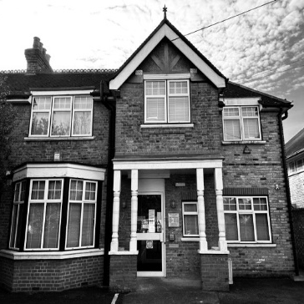
Broad Lane Surgery Newsletter
Spring 2024
https://broadlanesurgeryhampton.co.uk
Speedier repeat prescriptions:  If you are a smart phone or tablet user, ordering on-line is the quickest way to get prescriptions. You can either:  1. Download the ‘Patient Access’ app where you can book GP appointments, order repeat prescriptions and discover local health services. You can sign in with your NHS login, but you will need to ask the surgery reception for a one-time code to get your app linked to Broad Lane Surgery. This is the preferred and quickest method.  Or:  2. It is also possible to order via the Broad Lane website. Click on the home page (see top of this page) and then choose ‘How to order a repeat prescription’. Scroll down to find an on-line order form.  Social Prescribing at Broad Lane:  Social prescribing is a means of enabling GPs and other health care professionals to refer people of all ages to a range of local, non-clinical services. They can advise on a range of issues including, but not limited to, loneliness, cost of living concerns, low level mental health issues and complex social needs. A social prescriber has been assigned to Broad Lane surgery. | The importance of NHS screening:  Screening is a way of finding out if people have a higher chance of having a health problem, so that early treatment can be offered or informed decisions made. Please don’t refuse screening if it is offered to you. Cervical cancer screening is offered every 3 years for women aged 25 to 49, and every 5 years from the ages of 50 to 64. Breast screening is offered to women aged 50 to 70 to detect early signs of breast cancer. Women over 70 can self-refer. Everyone aged 60 to 74 is offered a bowel cancer screening home test kit every 2 years. If you're 75 or over, you can ask for a kit every 2 years by phoning the free bowel cancer screening helpline on 0800 707 60 60. Abdominal aortic aneurysm screening (AAA) is offered to men during the screening year (1 April to 31 March) that they turn 65 to detect abdominal aortic aneurysms (a dangerous swelling in the aorta). Men over 65 can self-refer.  Patient Participation Group (PPG)  Broad Lane Surgery patients can have their say by volunteering as a member of the Broad Lane Surgery’s Patient Participation Group (PPG). Ask the surgery reception for more information or send an email expressing your interest to swlicb.adminbroadlanesurgery@nhs.net

